**Project Proposal**

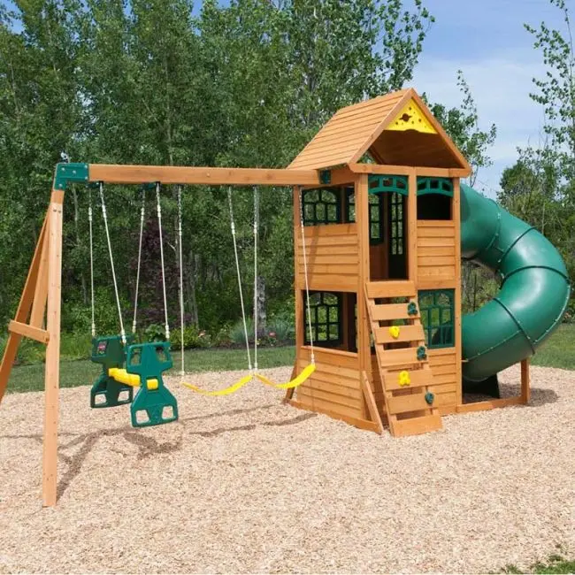

I have chosen a children’s outdoor playset for my scene I will be creating. The ground will be the starting point for me which will be the plane. It will be easy to build the rest of my scene after I use the plane as my flat surface to hold the rest of my objects. The reason I picked a child’s swing set is because it has multiple different shapes that I can use, and it is a great representation of multiple possibilities to recreate objects with multiple shapes. First, I will begin my structure with a cube and a pyramid to create the base. After that is created, I will be using a cylinder to create my slide that will go off the side of the cube/pyramid. I also will be using a pyramid for the far left of the structure that will be holding up the swings and the poles. There are multiple different objects to work with in this scene and there is many shapes I can use to re-create this.